System Requirements Statement (SRS)-

Digital Gram Panchayat

1. **INTRODUCTION………………………………………………………………………………………………………………………. 3**
2. **FUNCTIONAL REQUIREMENT…………………………………………………………………………………………………… 4**

2.1 User Module…….…………………………………………………………………………………………………………………….. 7

2.2 Admin Module……………………………………………………………………………………………………………………….. 8

2.3 PDO Module………………………………………………………………………………………………………………………….. 10

2.4 Use Case Diagram …………………………………………………………………………………………………………………. 15

# Introduction

This document explains the system requirements and scope for developing Digital Gram Panchayat.

Digital Gram Panchayat could divide the three main parts, User part,Admin part and the PDO part .

# 2.Functional Requirements

The Account part of Digital Gram Panchayat has three modules which are divided 16 processes described as below.

|  |  |  |
| --- | --- | --- |
| **No** | **BRS requirement ID** | **Description** |
| **2.1** | **User Module (Villagers)** | |
| **2.1.1** | **F1** | **Registration Process** |
| **2.1.2** | **F2** | **Login Process** |
| **2.1.3** | **F3** | **Browse Schemes** |
| **2.1.4** | **F4** | **Register Problems** |
| **2.1.5** | **F5** | **Delete Problems** |
| **2.1.6** | **F6** | **Insert Record (Birth,Date)** |
| **2.2** | **Admin Module (Gram Sevak)** | |
| **2.2.1** | **F7** | **Registration Process** |
| **2.2.2** | **F8** | **Login Process** |
| **2.2.3** | **F9** | **Document Approval Process** |
| **2.2.4** | **F10** | **Update / Delete Problems** |
| **2.2.5** | **F11** | **Upload Schemes** |
| **2.2.6** | **F12** | **Remove Schemes** |
| **2.3 PDO Module (Panchayat Development Officer)** | | |
| **2.3.1** | **F13** | **Login Process** |
| **2.3.2** | **F14** | **Check Reports** |
| **2.3.3** | **F15** | **Upload Schemes** |

## 2.1 User Module

* Villagers of the village are the user of system who can raise their problems and Stay connected with the System.

* He is also able to view the Problems as well as Schemes .

### 2.1.1 Registration Process

* Digital Gram Panchayat compels to create the account before using it. So, Digital Gram Panchayat should provide the function which makes users creates new account.
* When users creates new account, the function demands following information described as below.

1. Login information
2. Contact Details

* The Login information

The Login information consists of some items described as below.

1. UserID
2. Password
3. First Name
4. Last Name
5. E-mail address
6. User type
   * All items are compulsory demanded.
   * UserID

* The UserID should be unique. If the UserID correspond with not case-sensitive to other which is previously registered, the UserID should not be registered as an account.
  + Password
* The Password has constrains which makes the Password consists of more than or equal 8 and less than or equal 16 characteristics including characters described as below.

1. Numeric figure (at least one)
2. Capital alphabet (A-Z)(at least one)
3. Small alphabet (a-z)(at least one)
4. Special character (#, $, %, &, etc.) (at least one)

* The Password is masked by dummy characters. The re-entering Password is demanded.
* The Password must be encrypted in Digital Gram Panchayat.
  + User Type

The User Type falls into three categories described as below.

1.Villagers

2.Gram Sevak

3.PDO

* In an Account Creation Process, the user can select user.
* No one could select the PDO , because PDO is implemented to Digital Gram Panchayat System in advance.
* Contact Details
* The Contact Detail consists of some items described as below.

1. Permanent Address
2. Contact Phone No
   * All items are compulsory demanded.
   * Permanent Address

* Permanent Address should be filled.

### 2.1.2 Login Process

* Digital Gram Panchayat always compels user authentication before using itself except when a new account is successfully created.
* The user authentication demands UserID and Password. The UserID and the Password should be checked in two way.
  + First,The UserID and the Password should be existed and correct.
* If The UserID and the Password are not equal to what the user has registered, the user authentication cannot be provided.
  + Second, the User Type linked to the UserID should be "User".
* When the User Type is " User ", user can be placed on “Users Home”.
* Only when the check is successfully completed, user can be placed on respected page.

### 2.1.3 Browse Schemes

* Users can browse the schemes and apply for the same.

### 2.1.4 Register Problems

* User can register the problem.
* User can see issues raised by other users before before registration.

### 2.1.5 Delete Problems

* User can delete the problem whenever he wants.

### 2.1.6 Insert Records

* User can add required information about himself in to the system.
* User can insert birth records and required dates.

#### 2.2 Admin Module

* Gram sevak can update daily schedule on the portal.
* As well as advertisement can be shown on the application .

### 2.2.1 Registration Process

* Digital Gram Panchayat compels to create the account before using it. So, Digital Gram Panchayat should provide the function which makes users creates new account.
* When users creates new account, the function demands following information described as below.

1. Login information

2. Contact Details

* The Login information

The Login information consists of some items described as below.

1. UserID

2. Password

3. First Name

4. Last Name

5. E-mail address

6. User type

* + All items are compulsory demanded.
  + UserID
* The UserID should be unique. If the UserID correspond with not case-sensitive to other which is previously registered, the UserID should not be registered as an account.
  + Password
* The Password has constrains which makes the Password consists of more than or equal 8 and less than or equal 16 characteristics including characters described as below.

1. Numeric figure (at least one)
2. Capital alphabet (A-Z)(at least one)
3. Small alphabet (a-z)(at least one)
4. Special character (#, $, %, &, etc.) (at least one)

* The Password is masked by dummy characters. The re-entering Password is demanded.
* The Password must be encrypted in Digital Gram Panchayat.
  + User Type

The User Type falls into three categories described as below.

1.Villagers

2.Gram Sevak

3.PDO

* In an Account Creation Process, the user can select user.
* No one could select the PDO , because PDO is implemented to Digital Gram Panchayat System in advance.
* Contact Details
* The Contact Detail consists of some items described as below.

1. Permanent Address
2. Contact Phone No
   * All items are compulsory demanded.
   * Permanent Address

* Permanent Address should be filled.

### 2.2.2 Login Process

* Digital Gram Panchayat always compels user authentication before using itself except when a new account is successfully created.
* The user authentication demands UserID and Password. The UserID and the Password should be checked in two way.
  + First, The UserID and the Password should be existed and correct.
* If The UserID and the Password are not equal to what the user has registered, the user authentication cannot be provided.
  + Second, the User Type linked to the UserID should be "Admin".
* When the User Type is " Admin ", user can be placed on “Admins Home”.
* Only when the check is successfully completed, Admin can be placed on respected page.

### 2.2.3 Document Approval Process

* Gram Sevak can check and approve the information updated by the users .
* Gram Sevak can update information regarding the scheme approval .

### 2.2.4 Update Problems

* Admin can Update the status of the problem .
* Admin Can delete the Problems under certain conditions.

1. If the problem has been solved and still persists many time.
2. The problems which does not comes under the system control.

### 2.2.5 Upload Schemes

* Admin can Upload new Schemes.
* All the schemes will be visible by the users .
* Scheme related updates will be maintained by the Gram sevak

### 2.2.6 Remove Schemes

* Admin can Remove Expired Schemes.
* Removed schemes will not been visible any more .

#### 2.3 PDO Module

* PDO have all controls on the system.

### 2.3.1 Login Process

* Digital Gram Panchayat always compels user authentication before using itself except when a new account is successfully created.
* The user authentication demands UserID and Password. The UserID and the Password should be checked in two way.
  + First, The UserID and the Password should be existed and correct.
* If The UserID and the Password are not equal to what the user has registered, the user authentication cannot be provided.
  + Second, the User Type linked to the UserID should be "Admin".
* When the User Type is " Admin ", user can be placed on “Admins Home”.
* Only when the check is successfully completed, PDO can be placed on respected page.

### 2.3.2 Check Reports

* PDO Will check the Reports submitted by the Gram Sevak .
* PDO can check or view the status of the problems.

### 2.3.3 Upload Schemes

* PDO can Upload new Schemes.
* All the schemes will be visible by the users .

#### 2.4 Use Case Diagram

**User:**

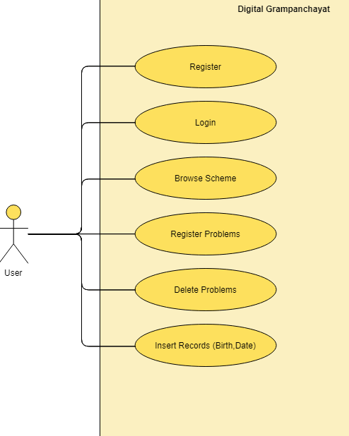

**User:**

1. In User use case diagram user is the Actor.
2. User can handle following use cases:
3. Register
4. Login
5. Browse Schemes
6. Register Problems
7. Delete Problems
8. Insert Record(Birth , Date)

**Admin:**

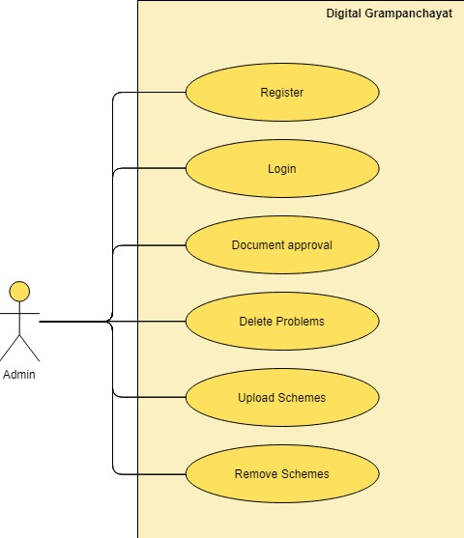

1. In Admin use case diagram Admin is the Actor.
2. Admin can handle following use cases:
3. Register
4. Login
5. Document Approval Process
6. Update/Delete Problems
7. Upload Schemes
8. Remove Schemes

**PDO:**

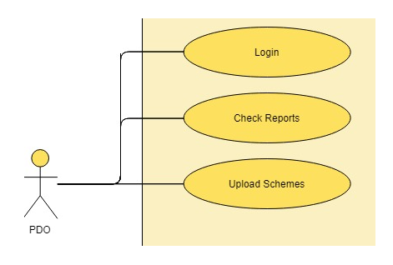

1. In PDO use case diagram PDO is the Actor**.**
2. PDO can handle following use cases:
3. Login
4. Check Reports
5. Upload Schemes